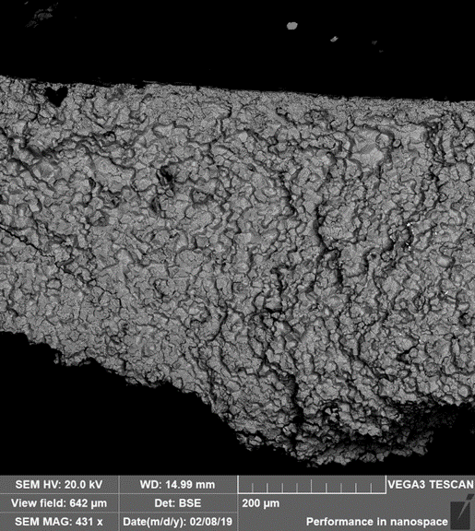

|  |  |  |  |
| --- | --- | --- | --- |
| **Project** | TLR 19-100 | **Analyst** | Andy Fisher |
| **Particle** | Chip 42 | **Department** | PS-DP/ENP1-NA |
| **Material Class** | Aluminum | **Instrument** | EDS |
| **Description** |  | | |
| **Conclusion** |  | | |

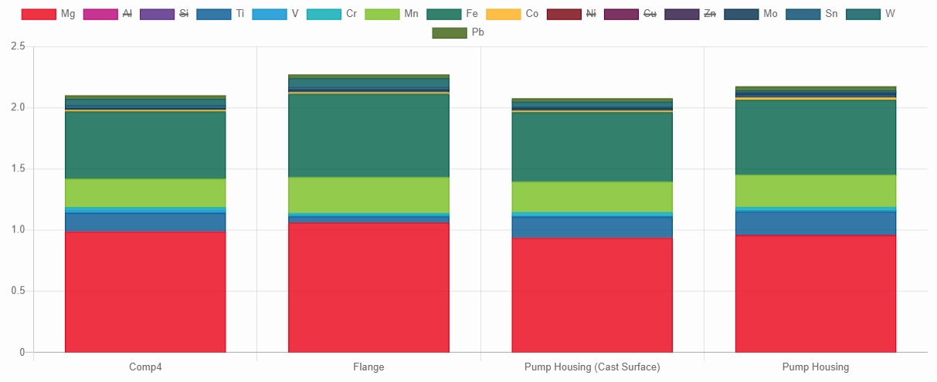

**Matches**:

|  |  |  |  |  |  |  |  |  |  |  |
| --- | --- | --- | --- | --- | --- | --- | --- | --- | --- | --- |
| **#** | **Match** | **Product / Component** | **Date** | **Al** | **Si** | **Cu** | **Mg** | **Ni** | **Fe** | **Zn** |
| 0 | 100% | TLR 19-100 / Chip 42 | 12/18/2018 | 82,78 ± 1,43 | 12,2 ± 1,43 | 82,78 ± 1,43 | 12,2 ± 1,43 | 12,2 ± 1,43 | 12,2 ± 1,43 | 12,2 ± 1,43 |
| 1 | 99 % | CP4 / Cylinder Head | 12/18/2018 | 82,78 ± 1,43 | 12,2 ± 1,43 | 82,78 ± 1,43 | 12,2 ± 1,43 | 12,2 ± 1,43 | 12,2 ± 1,43 | 12,2 ± 1,43 |
| 2 | 88 % | CP4 / Valve Plate | 12/18/2018 | 82,78 ± 1,43 | 12,2 ± 1,43 | 82,78 ± 1,43 | 12,2 ± 1,43 | 12,2 ± 1,43 | 12,2 ± 1,43 | 12,2 ± 1,43 |
| 3 | 88 % | CP4 / Camshaft | 12/18/2018 | 82,78 ± 1,43 | 12,2 ± 1,43 | 82,78 ± 1,43 | 12,2 ± 1,43 | 12,2 ± 1,43 | 12,2 ± 1,43 | 12,2 ± 1,43 |
| 4 | 89 % | CP4 / Cylinder Head | 12/18/2018 | 82,78 ± 1,43 | 12,2 ± 1,43 | 82,78 ± 1,43 | 12,2 ± 1,43 | 12,2 ± 1,43 | 12,2 ± 1,43 | 12,2 ± 1,43 |
| 5 | 88 % | CP4 / Valve Plate | 12/18/2018 | 82,78 ± 1,43 | 12,2 ± 1,43 | 82,78 ± 1,43 | 12,2 ± 1,43 | 12,2 ± 1,43 | 12,2 ± 1,43 | 12,2 ± 1,43 |
| 6 | 88 % | CP4 / Camshaft | 12/18/2018 | 82,78 ± 1,43 | 12,2 ± 1,43 | 82,78 ± 1,43 | 12,2 ± 1,43 | 12,2 ± 1,43 | 12,2 ± 1,43 | 12,2 ± 1,43 |
| 7 | 89 % | CP4 / Cylinder Head | 12/18/2018 | 82,78 ± 1,43 | 12,2 ± 1,43 | 82,78 ± 1,43 | 12,2 ± 1,43 | 12,2 ± 1,43 | 12,2 ± 1,43 | 12,2 ± 1,43 |
| 8 | 78 % | CP4 / Valve Plate | 12/18/2018 | 82,78 ± 1,43 | 12,2 ± 1,43 | 82,78 ± 1,43 | 12,2 ± 1,43 | 12,2 ± 1,43 | 12,2 ± 1,43 | 12,2 ± 1,43 |
| 9 | 78 % | CP4 / Camshaft | 12/18/2018 | 82,78 ± 1,43 | 12,2 ± 1,43 | 82,78 ± 1,43 | 12,2 ± 1,43 | 12,2 ± 1,43 | 12,2 ± 1,43 | 12,2 ± 1,43 |
| 10 | 78 % | CP4 / Valve Plate | 12/18/2018 | 82,78 ± 1,43 | 12,2 ± 1,43 | 82,78 ± 1,43 | 12,2 ± 1,43 | 12,2 ± 1,43 | 12,2 ± 1,43 | 12,2 ± 1,43 |